“Boop ‘em” Advanced Higher Computing Project Record of Progress

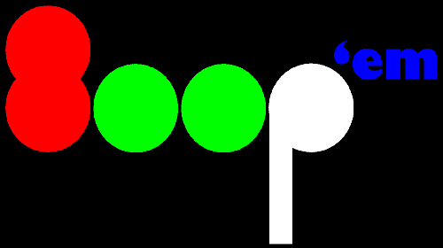

By Craig Methven

Advanced Computing Project Record of Progress

30/09/2017 – Project proposal

I formulated a plan of what I would like to for the project and proceeded to write out how I may code it in very simple terms so that I knew if it was feasible or not to code. I found that it was after doing some research into python, how to create interfaces and how to create a 2D array in a 2D array.

01/09/2017 – Project proposal

Found the Program “Project Libre” which I can use to help me keep to a time schedule on this project. I proceeded to start a Gantt chart on it marking what I had to do to complete the project up until testing.

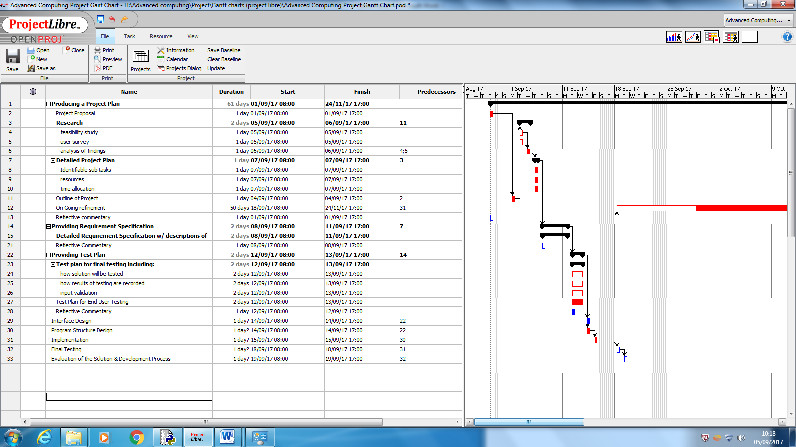

05/09/2017 – Project proposal

I started work on marking out the project plan creating a first draft of the: outline of project, feasibility study, sub tasks, resources and time allocation. For time allocation and sub tasks I used project libre to help with keeping my time as well as marking resources on it.

08/09/2017 – Project proposal

I created the documentation for the end user and knowledge and skills needed. The end user was easy to see due to the type of game I am creating although the knowledge and skills I found more difficult as I don’t know python that well so didn’t know what type of code I would use to create the interface and if that needed anything in particular making it hard to know if I needed to spend much time researching it

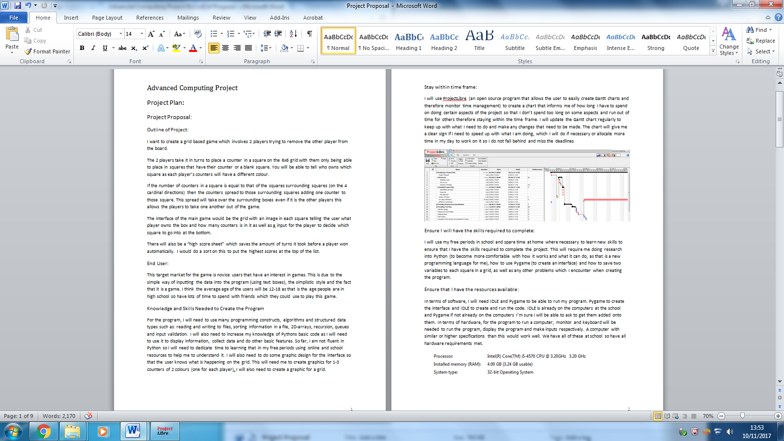

15/09/2017 – Project proposal

I spent time creating a table showing what time I estimate I will do everything in and what date I would like it finished by to stay on task. Project Libre helped with the creation of this I already used it to keep track of when the tasks are meant to be finished.

22/09/2017 – Research

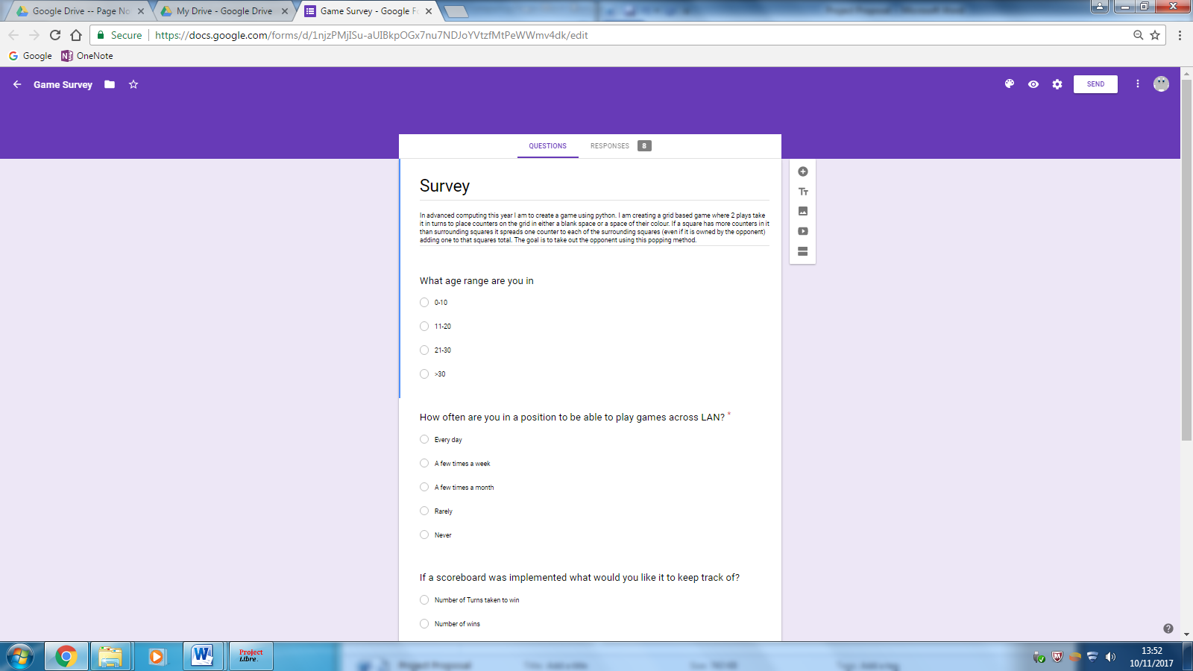I did research into how feasibly it would be to create the game by looking at copy right, resources needed and techniques needed. Copy right was the hardest to do as I had to look through government websites to see the wording of the laws to do with copy right. Techniques was also difficult though as I don’t know python too well.

25/09/2017 – Research

I created a survey asking people about if they would play the game and what they would like from it. I wanted to not make it too long so that it didn’t hassle people to answer it. I then did more research into py game and found how to draw different shapes of different colours on the screen making it possible to create a grid and display the counters on the grid. I also did the end user requirements. To do this I used [www.pygame.org](http://www.pygame.org) and [www.effbot.org/tkinterbook](http://www.effbot.org/tkinterbook) before deciding to use only Pygame

27/09/2017 – Research

I did analysis of the findings and gladly found that it was possible to make the game and that people wanted to see it and most people will be able to play it.

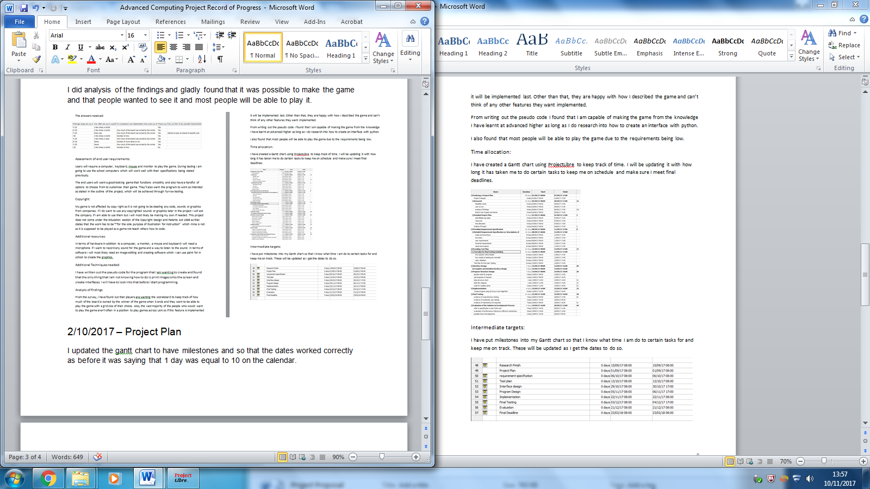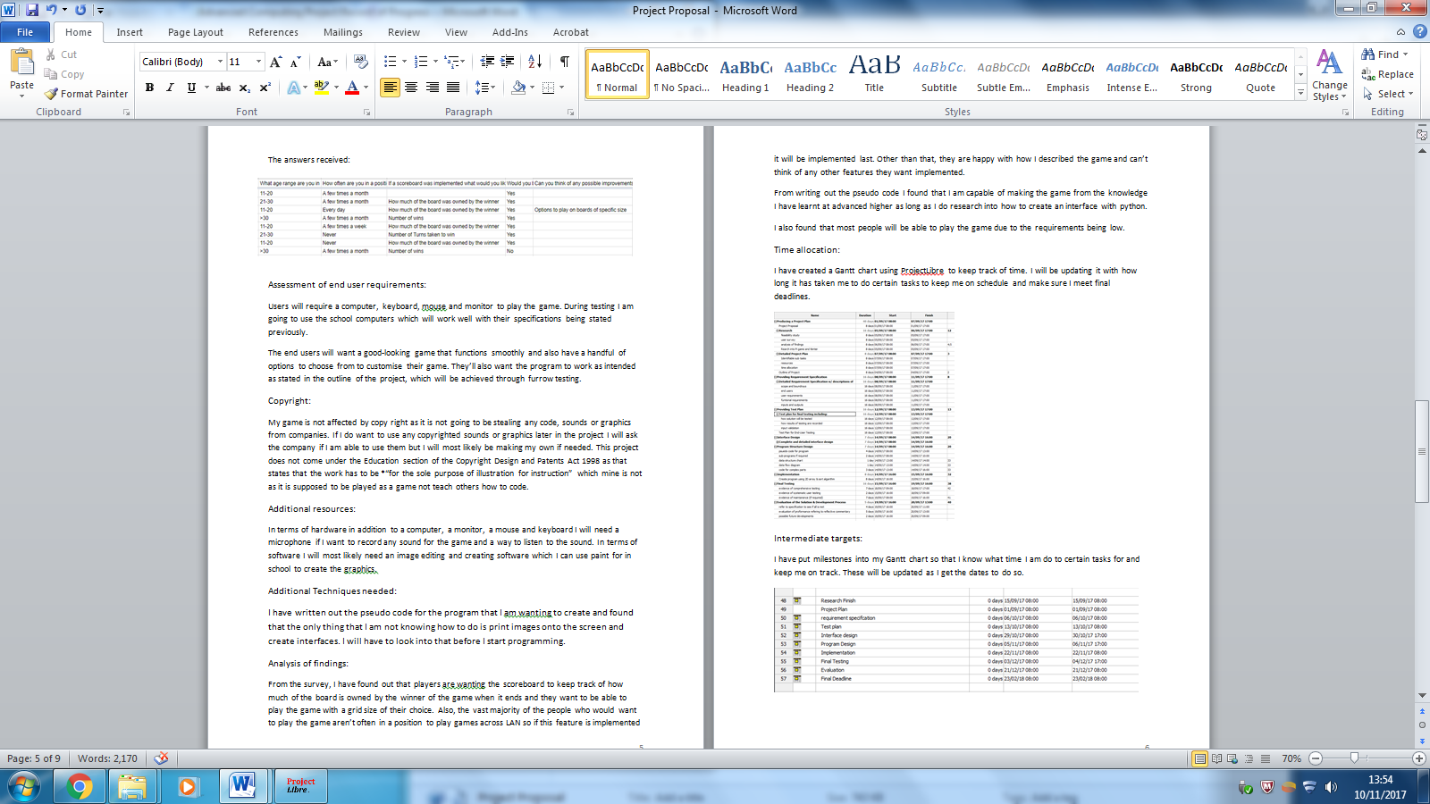

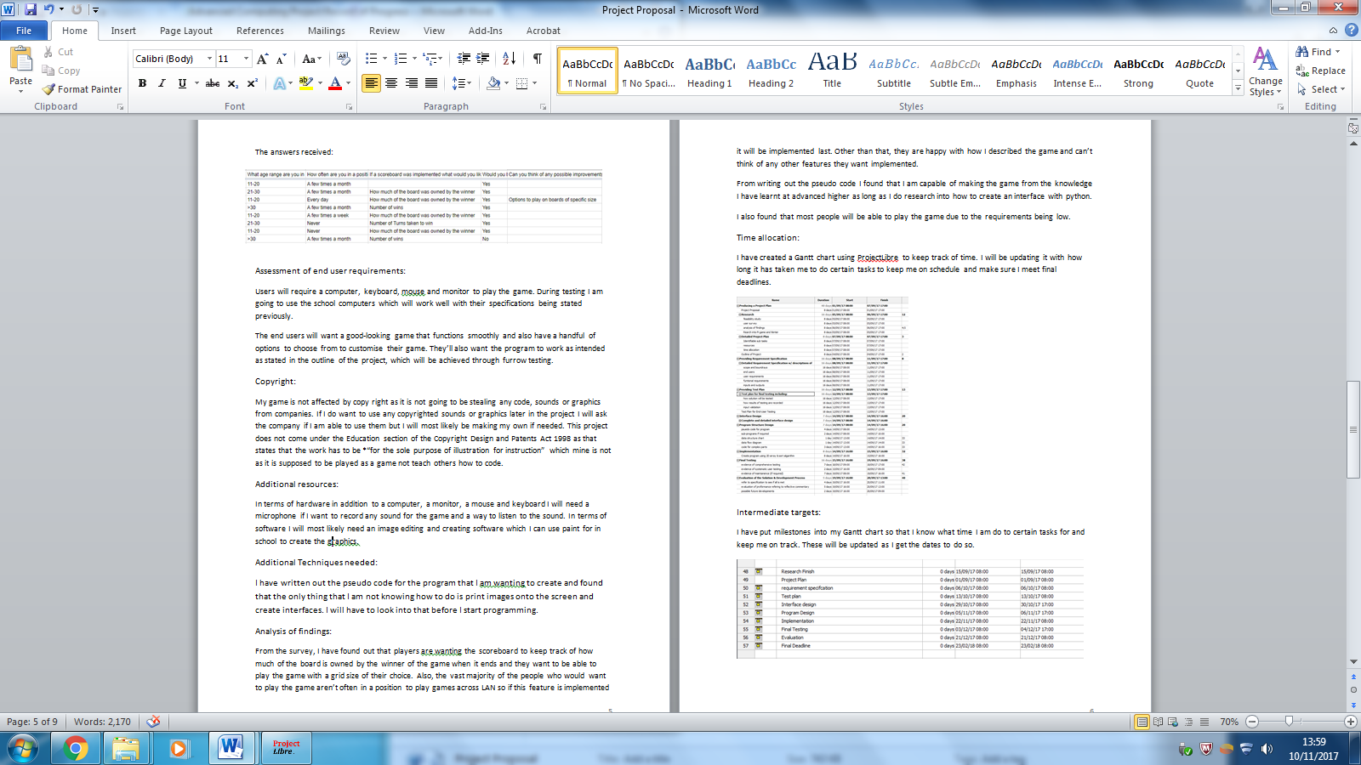 2/10/2017 – Project Plan

I updated the gantt chart to have milestones and so that the dates worked correctly as before it was saying that 1 day was equal to 10 on the calendar.

6/10/2017 – Project Plan

I updated the gantt chart again to have more stages as before it only went up to testing so now it goes up to the end of the project.

9/10/2017 – Requirement Specification

I did the purpose of the solution stating what I want the program to do, which I didn’t have a problem with. I then added in the scopes and boundaries of the project detailing how I want the program to work and what is feasible within the time limit. I found writing things that I could add but aren’t needed quite hard but managed to get quite a few ideas of possible features.

16/10/2017 - Requirement Specification

I used results from the survey to find the end users of the game. I also created the user requirements which were also helped by the user survey from previous. I continued to made the functional requirements part of the documentation which was easy enough to create stating the bare minimum that the program needed

20/10/2017 – Requirement specification

I added an inputs and outputs table to the requirement specification showing all the variables that will need to be inputted and outputted.

27/10/2017 – Test plan

I wrote how I will be testing the program and the input validation. The input validation was a good next step after doing the input and output table as it was all fresh in my mind.

01/11/2017 – Test plan

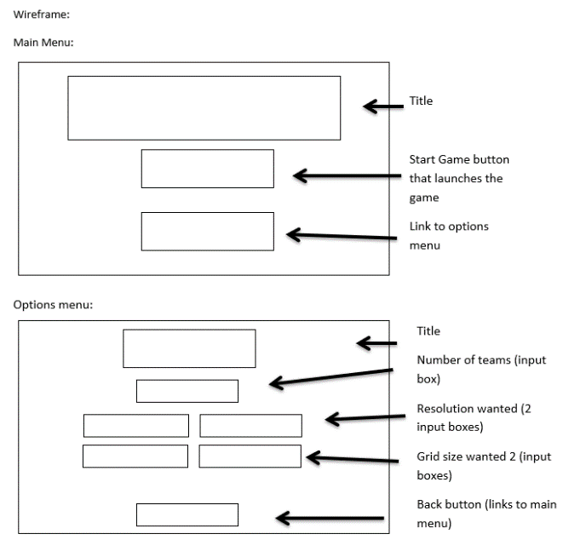I went onto create how I will store the results from the testing and saying how I will see if the end user is happy with the program.

06/11/2017 – Interface design

I made the layouts of each of the three screens using wire frames and labelling every object. This made me see that I had to do more research into TKinter and Pygame to be able to have the links I want between the pages and also the input boxes for the changeable parts of the game such as the number of teams, which I then went and did. I would like to use these interfaces though as they meet the scope of the requirement specifications having everything that is required of the program in them

10/11/2017 - Interface design

I wrote about why each element of the interface is there (it’s purpose), clearly stating the reasoning behind every object on the interface. I then showed the relationships between each screen showing that the main menu would need to be accessed to go from the options menu to the game and vice versa. I made the screens look like this as it made it easy for the users to navigate around with no complicated buttons or anything not labelled. It also suits in end user as the end user are teens so don’t want it being setup in a way that makes it look old, and this design makes it look clean and modern as well as having the functionality.

15/11/2017 - Interface design

I wrote the expected inputs and outputs of each part of the interface design. The grid was the most challenging part as I had to say what I expected in each situation if a counter was clicked on whether it be on a corner or edge or not.

17/11/2017- program / data structure design

I completed the variables and files that I will use during the coding. This was interesting as I haven’t done the code yet so I had to figure out what each sub routine would need and write down the main variables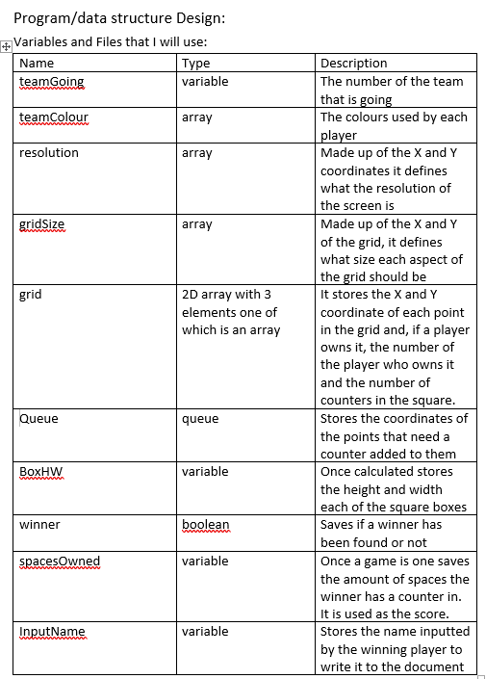

21/11/2017- program / data structure design

I starting doing the pseudo code and did the pseudo code to find the height of the boxes, creating the 2D array, and changing team. The code for changing team was fun to figure out as it uses recursion in it to make it work. Finding the height of the boxes was also quite good as I figured out the maximum height and width the boxes can be and still fit on the screen.

24/11/2017- program / data structure design

I then did the pseudo code for the popping mechanic in the game and the sorting of the scores file. The sorting was just an insertion sort so was quick to do although taking in the names with the numbers was a bit of a pain as I had to store them in a 2D array. The popping mechanics were alright to figure out though. The pseudo code was done in a way that it includes all of the items in the scope of the requirement specification as those are the main parts of the program that need to be completed before the game runs.

28/11/2017- program / data structure design

I proceeded to do the data flow between the sub routines which was challenging as I haven’t programmed it yet so I don’t know if I am missing any important sub routines so I may need to go back and change his later.

29/11/2017- Implementation

Started writing the code starting with defining the variables needed and drawing the grid using pygame. This means it needed to figure out the maximum size of the squares used to draw the grid. When I tested it though I found that the grid is not centred though so need to find a way to do that.

1/12/2017- Implementation

I figured out a way to centre the grid vertically and horizontally, making sure to make sure that it is the max size possible when doing so which was quite challenging but turned out well.

5/12/2017- Implementation

I realised that the game looks better horizontally instead of vertically so I made it so that the game always has more rows and the resolution is larger horizontally than vertically. I then started creating the 2D array which the background of the game is played on making sure that each space in the grid is capable of storing the team in that square, the number of counters in it and the coordinates of the square it refers to

6/12/2017- Implementation

I then worked on getting it so that the grid would display a counter in the grid square clicked on so I first had to find out which square was clicked on and do calculations with it to see where the player has clicked.

8/12/2017- Implementation

I created the graphics of the counter appearing, making different ones depending on if there was 1, 2 or 3 in the counters. I then started working on the popping mechanism although didn’t get it finished

12/12/2017- Implementation

I finished getting the popping mechanism working making sure that the counters only popped if needed to at that time which needed a lot of logic.

15/12/2017- Implementation

I found a bug that made it so that the user count place on the edges of the grid so I worked on fixing that problem which involved changing a lot of the sub routines.

19/12/2017- Implementation

I then worked on the mechanic to change the teams which needed recursion to function and then made sure all the features worked for the different players, including the counters changing to the appropriate colour.

22/12/2017- Implementation

I then made it so that the game checked to see if someone had one at the end of every round but came across that it was possible for a game to never end if it only checked that often so also had to check to see if the game had run more than needed to win the game. I then made it so that the winner is identified.

5/01/2018- Implementation

I then made it so that it checked to see how many counters the winner had before they won before creating a win screen for the winner to input their username although I spent most of the time doing the graphics for it.

9/01/2018- Implementation

I then finished off the winning screen so that the user could only input 5 characters and the winners colour and number is displayed, all using pygame.

12/01/2018- Implementation

I then found a bug that meant that if the player clicked off of the grid it would place in the nearest square or crash the game so I proceeded to fix that bug. I then implemented that the colour of the grid changed to match the colour of the player going. This however didn’t work straight away so needed to do some fixing to get it to work.

16/01/2018- Implementation

I then made it so that the winner’s inputted name and their score are saved to a document so it can be read later. I then started work on the main menu creating the logo for the game and creating the buttons.

19/01/2018- Implementation

After getting the play game button to play the game and the winners input to lead back to the main menu, I started work on the instructions menu creating the menu for that,

23/01/2018- Implementation

I then implemented the high scores menu sorting the inputted data into the correct order then displaying the top 10. I came across an issue where the sort wouldn’t work as it was not put into an int statement which took a while to figure out.

24/01/2018- Implementation

I did the options menu allowing users to input the colour of each player, the grid size, the resolution and the number of players. It was troublesome to read in the colours from the document as it read it in as a string when it needed a tuple but I found a work around to that

30/01/2018- Implementation

I did some final bug testing and fixes making sure that everything worked as intended.

31/01/2018 – Testing

I completed all of the testing for the spreading of 2 counter, the spreading of 3 counters, spreading of 4 counters, closing each page, changing the resolution and changing the grid size. This was easy to do and didn’t come across any bugs in the program while doing so.

06/02/2018 – Testing

I completed the testing for the changing of colours, changing the number of teams and the validation on the options menu and winners input. I was happy to see that the program was working as intended throughout and that the testing showed this.

07/02/2018 – Testing

I wrote up what I found from each test as well as created the end user testing survey and started asking people to test the game. I wasn’t quite sure what to put in the end user survey but ended up with some nice questions. I didn’t want to make it too long because then I may scare people off from doing it.

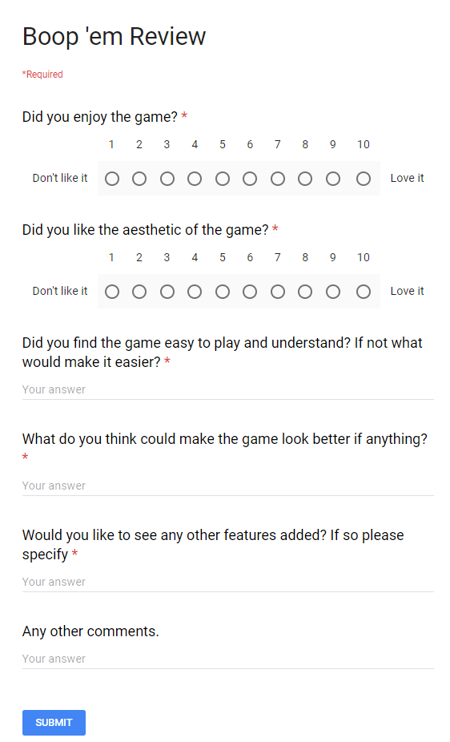

13/02/2018- Evaluation

I completed evaluating how it meets the requirement specification, evaluating the testing and evaluating the end user testing. The end user testing was challenging to evaluate as there was so many different thoughts and opinions on the game as well as good ideas to implement.

16/02/2018- Evaluation

I completed the conclusion by talking about further development, making a conclusion about the solution, evaluating the development process and evaluating my performance. So, I have now completed all the different parts which I need to complete.

20/02/2018- Finishing Touches

I went back and edited the interface designs as I added more screens by adding more things from the boundaries into the program. I also added some of the sub routines I used into the data flow diagram.

21/02/2018- Finishing Touches

I did some formatting of the document adding a contents and title page. I also fixed some spelling mistakes and other errors after checking it all through. I also changed some of the interface designs as I saw that they did not match the ones in the program.